TRƯỜNG TIỂU HỌC HOÀNG DIỆU
Thứ năm ngày ….. tháng … năm 2021
Họ và tên: ………………………………..
Lớp: Năm/…
TUẦN 23 - MÔN TIẾNG ANH LỚP 5
Unit 9: Will it really happen? (Lesson 1-6)

- Look at the pictures and write the correct words:

- 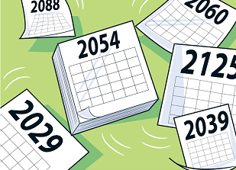 _____________________

- 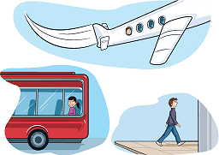 _____________________

-  _____________________

- 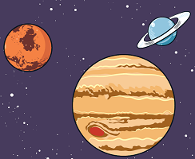 _____________________

- 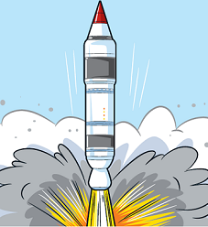 _____________________

- 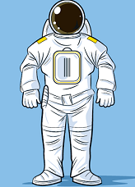 _____________________

-  __________________
-  ____________________

- Read and circle the correct answers:

- Andy (go) ________ back to Viet Nam next week.
A. go
B. will go
C. went
- Lucy (not visit) ________ her grandma this weekend.
A. doesn’t visit
B. didn’t visit
C. won’t visit
- “________ you stay home for 15 days?” – “Yes, we will.”
A. Will
B. Do
C. Did
- “Will they finish their work before 12 p.m.?” – “No, they________.”
A. will
B. won’t
C. do
- He (help) ________his dad repair the chair tomorrow.
A. helps
B. helped
C. will help

- Look at the pictures, read the questions and circle the correct answers:

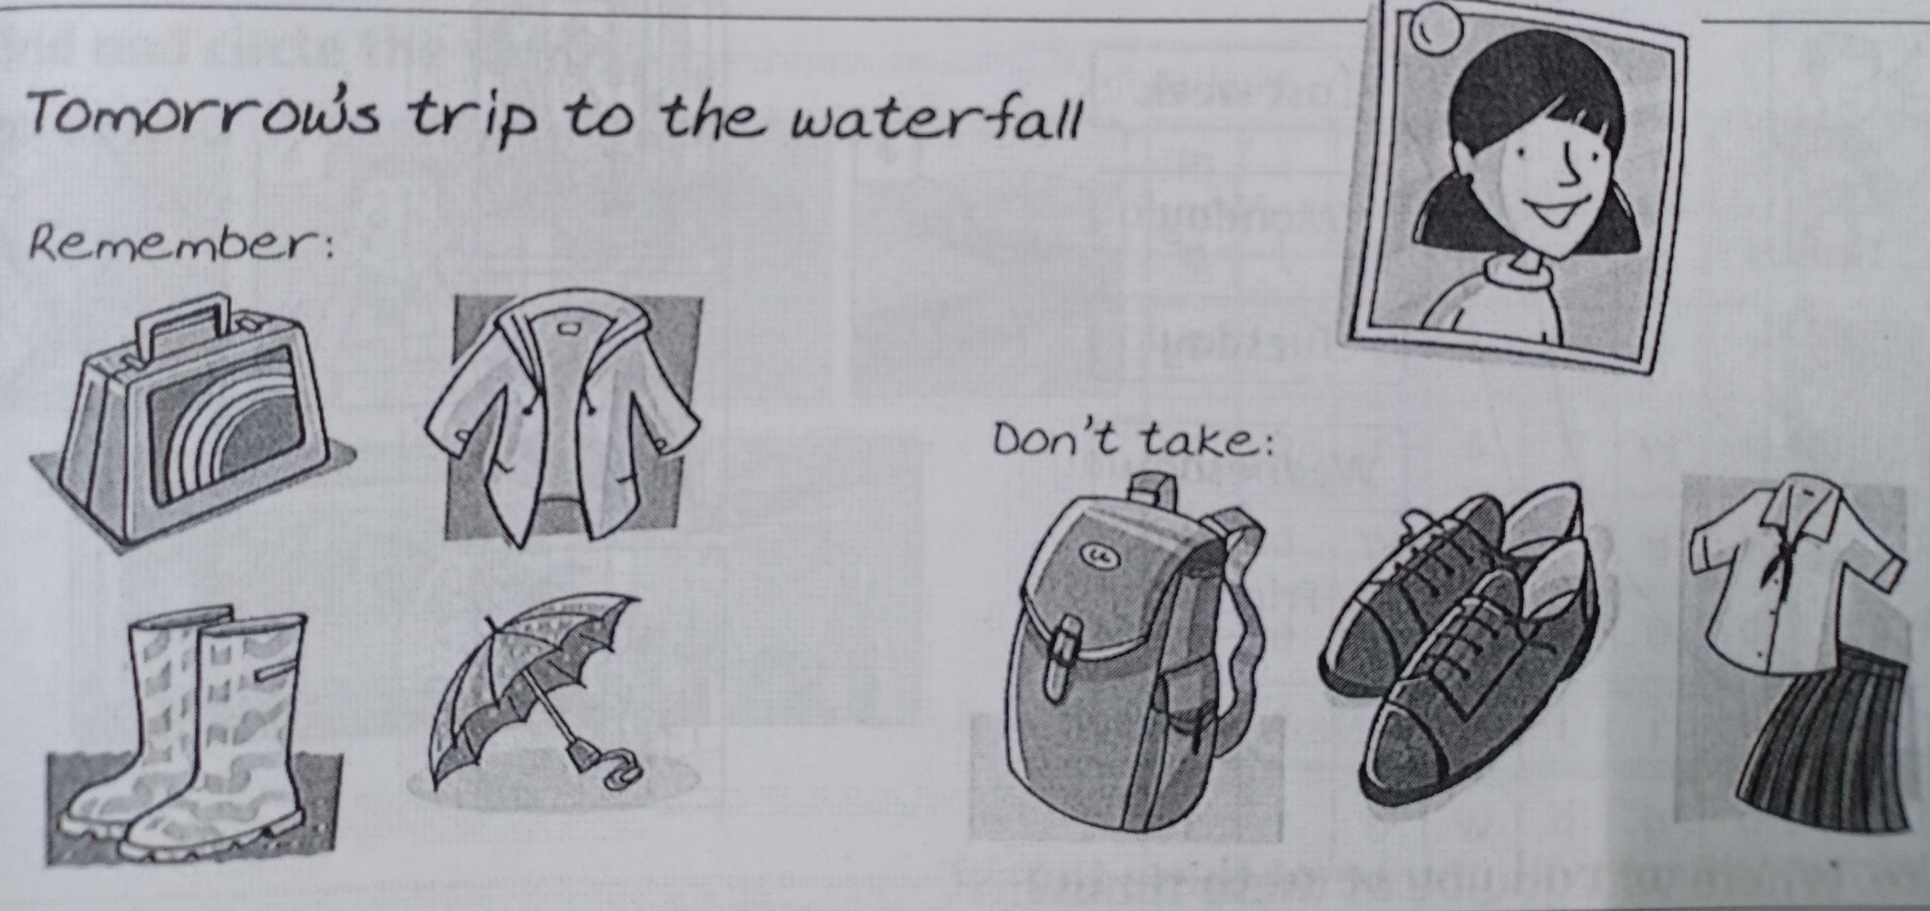

1. Will she take an umbrella?
________________________
2. Will she take her school bag?
________________________
3. Will she take her school uniform?
________________________
4. Will she take her lunchbox?
________________________
5. Will she take her raincoat?
________________________

- Read and answer the questions. Circle A, B, or C:
Next Friday, Khang will go to Hoa’s birthday party. Hoa will be 10 years old. He will give Hoa a T-shirt as a present. He won’t wear his uniform. Instead he will wear black pants and a white shirt. In the party, he will stand on a stage and play the violin. He hopes that Hoa will be surprised and happy.

- ………, Khang will go to a birthday party.
A. Tomorrow
B. Next Sunday
C. Next Friday
- He will give Hoa……….
- a teddy bear
- a doll
- a T-shirt

- He won’t wear………
A. his uniform
B. a white shirt
C. black pants
- In the party, he will play…….
A. the drum
B. the violin
C. the piano

--------- THE END ---------

ANSWER KEY:
I. Look at the pictures and write the correct words:

1. the future
2. travel
3. the sun
4. planets
5. rocket
6. astronaut
7. star
8. spaceship

II. Read and circle the correct answers:
1. B
2. C
3. A
4. B
5. C
III. Look at the pictures, circle the correct answers:
1. Yes, she will.
2. No, she won’t.
3. No, she won’t.
4. Yes, she will.
5. Yes, she will.
- Read and answer the questions. Circle A, B, or C:
1. C
2. C
3. A
4. B

